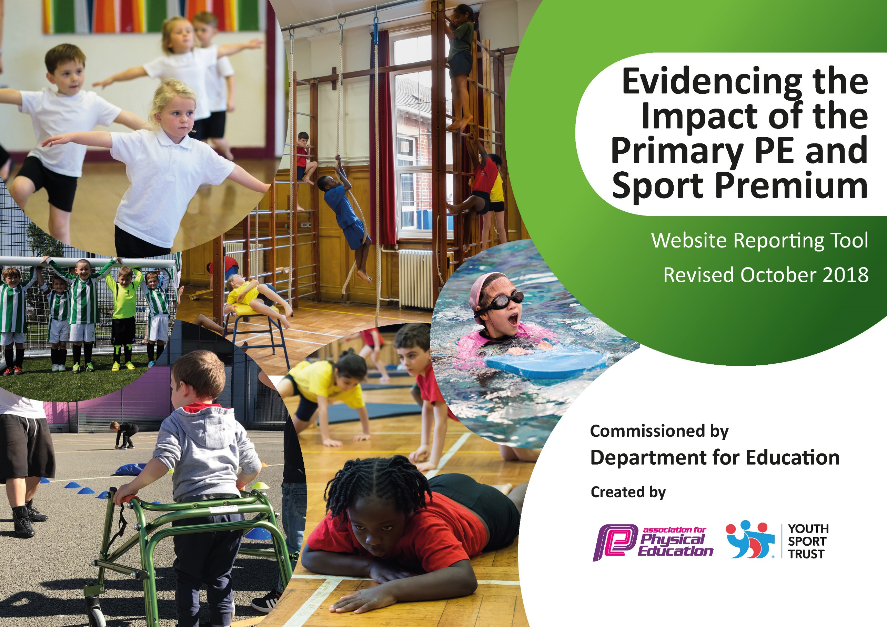
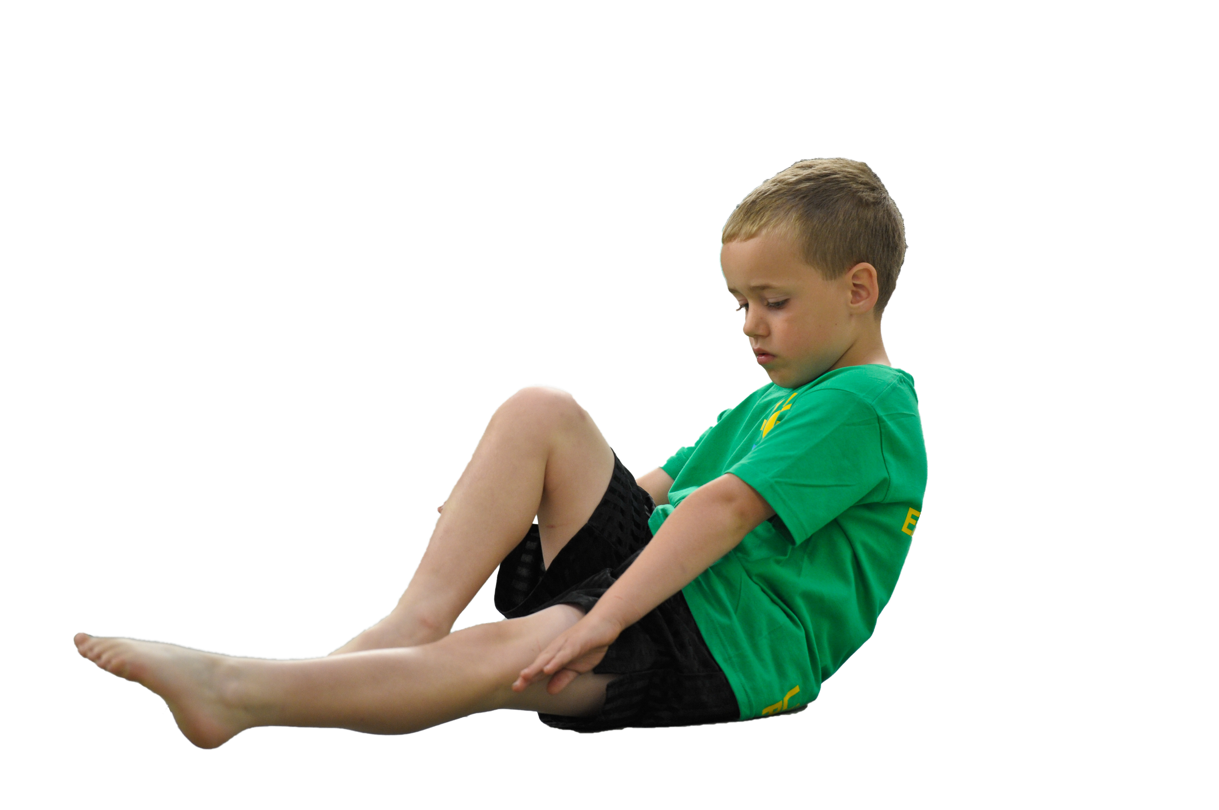
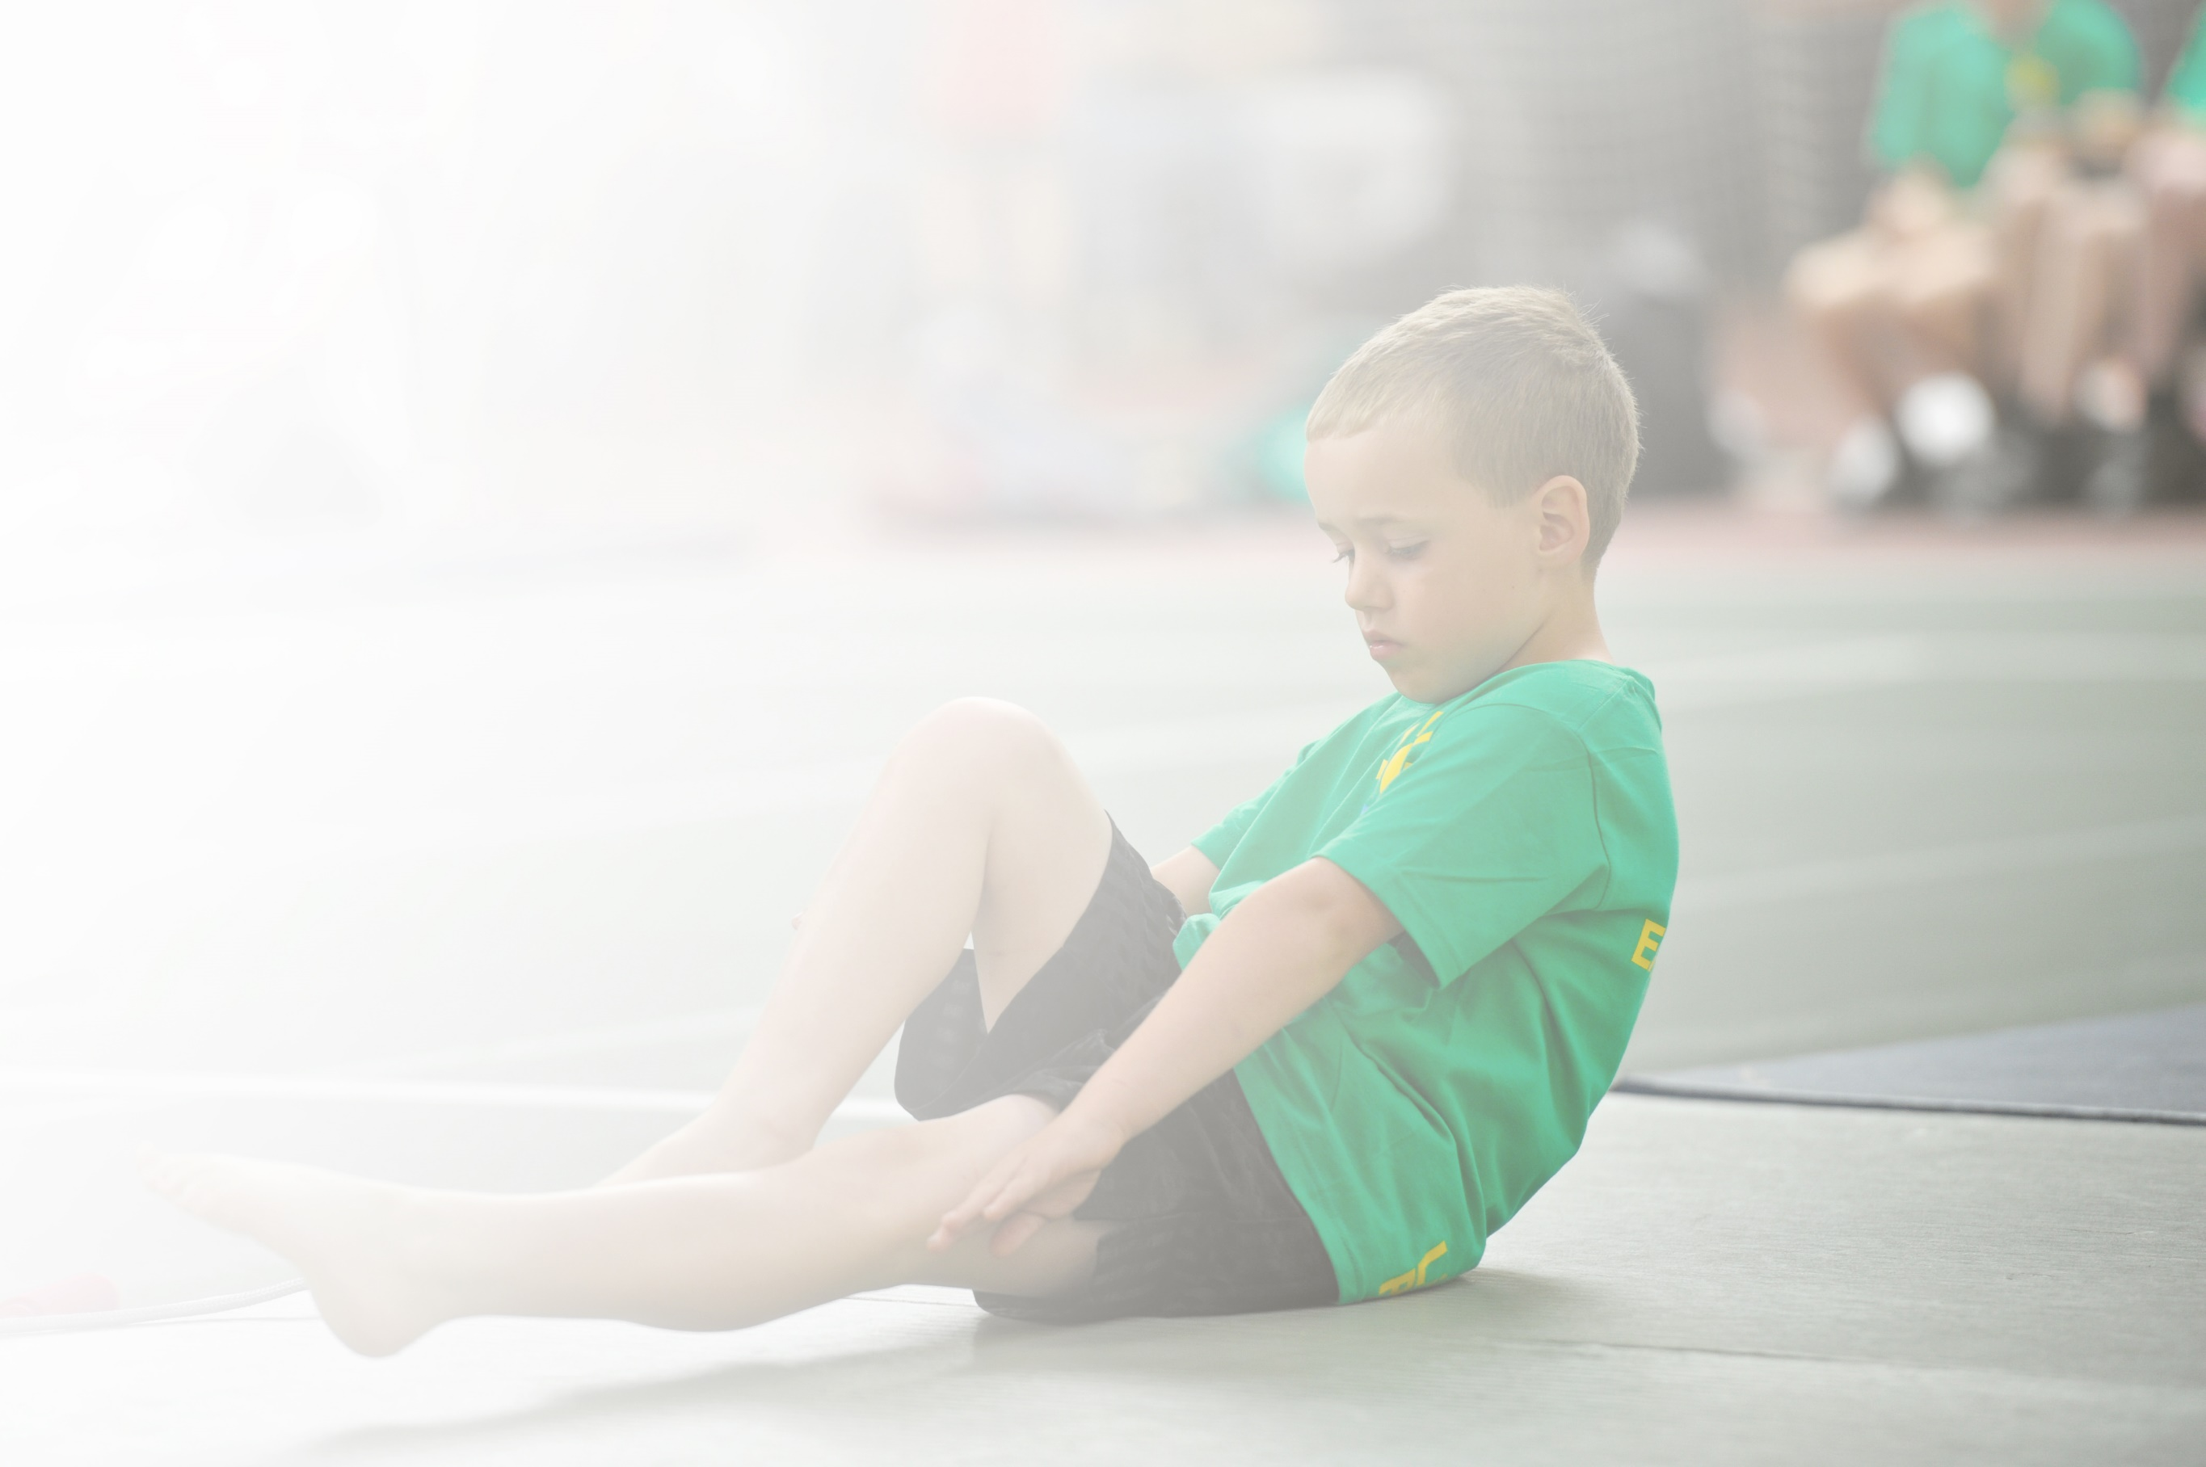
Schools must use the funding to make additional and sustainable improvements to the quality of Physical Education, Sport and Physical Activity (PESPA) they offer. This means that you should use the Primary PE and Sport Premium to:

- Develop or add to the PESPA activities that your school already offer
- Build capacity and capability within the school to ensure that improvements made now will benefit pupils joining the school in future years

Please visit gov.uk for the revised DfE guidance including the 5 key indicators across which schools should demonstrate an improvement. This document will help you to review your provision and to report
your spend. DfE encourages schools to use this template as an effective way of meeting the reporting requirements of the Primary PE and Sport Premium.

We recommend you start by reflecting on the impact of current provision and reviewing the previous
spend. Under the Ofsted Schools Inspection Framework, inspectors will assess how effectively leaders use the Primary PE and Sport Premium and measure its impact on outcomes for pupils, and how effectively governors hold them to account for this.

Schools are required to publish details of how they spend this funding as well as on the impact it has on pupils’ PE and sport participation and attainment by the end of the summer term or by 31 July 2019 at the
latest.
We recommend regularly updating the table and publishing it
on your website throughout the year, as evidence of your
ongoing review into how you are using the money to
secure maximum, sustainable impact. To see an
example of how to complete the table please
click HERE.

Support for review and reflection - considering the 5 key indicators from DfE, what development needs are a priority for your setting and your students now and why? Use the space below to reflect on previous spend, identify current need and priorities for the future.

Key achievements to date from 2019/20 | Areas for further improvement for 2020/21 and baseline evidence of need:
- All children from Y1 to Y6 do the fit in fifteen at least three times per week.  - Pupil surveys show children enjoy the variety of fit-in-fifteen rather than the single activity of the daily mile.  - Active learning part of the monitoring and review cycle. Active learning part of the teaching and learning culture.  - Pupil voice showed the children enjoyed the new equipment, particularly the construction equipment in KS1.  - Line marking in KS2 enabled the creation of distinct areas of activity on the playground.  - Equipment such as basketball hoops enabled a range of ball games to take places.  - Brain breaks and chunked learning are used by all classes but utilised to a greater extend when this is appropriate to the class.  - Two PE lessons per week.  - Active playtimes.  - PE assessment after each unit of work and inputting levels once per year.  - Resources altered in distribution depending on the units of work being taught. The outdoor shed is used for outdoor PE resources – Autumn invasion games, Winter invasion games, Spring – athletics and Summer striking and fielding games with resources not being used outdoors stored in the cupboard off the hall with gymnastics equipment.  - 55% [target 60%] of KS1 children participated in school sporting clubs.  - 85% [target 90%] of KS2 children took part in a school sporting club.  - 85% [target 90%] of KS2 disadvantaged children took part in a school sporting club. | - Fit-in-fifteen to be part of all classes recovery curriculum with two opportunities to engage in this each day.  - Pupil voice to be a key driver in shaping the fit-in-fifteen programme with termly surveys used to assess enjoyment [Oct HT, Feb HT and May HT].  - To evaluate ways to ensure active learning takes place in Covid-secure ways.  - Further extend the opportunities for children to be active in Covid secure ways at playtime and dinner time including year group play equipment.  - Complete pupil well-being surveys before the children return to school in September 2020.  - Broaden the range of sporting clubs based on pupil voice and to include disadvantaged pupils.  - To use the PE specialist to plan and assess learning based on gaps from 2019/20.  - Resources ordered to support outdoor PE in particular and also fit-in-fifteen.  - Consider competitions between class bubbles and in class bubbles in school which can take place in Covid secure ways, particularly focusing on Y3 and Y4 who took part in less competitions than Y5 and Y6 last year.

Meeting national curriculum requirements for swimming and water safety | Please complete all of the below:
What percentage of your current Year 6 cohort swim competently, confidently and proficiently over a distance of at least 25 metres?
N.B. Even though your children may swim in another year please report on their attainment on leaving
primary school.
What percentage of your current Year 6 cohort use a range of strokes effectively [for example, front crawl, backstroke and breaststroke]?
What percentage of your current Year 6 cohort perform safe self-rescue in different water-based situations?
Schools can choose to use the Primary PE and Sport Premium to provide additional provision for swimming but this must be for activity over and above the national curriculum requirements. Have you used it in this way?

Action Plan and Budget Tracking
Capture your intended annual spend against the 5 key indicators. Clarify the success criteria and evidence of impact that you intend to measure to evaluate for students today and for the future.

Academic Year: 2020/21 | Total fund allocated: £19,740 2020/21 allocation and funds carried forward to 2020/21  £7990.16 which was unspent from 2019/20  Total: £27,730.16 | Date Updated: 02.09.20 & 28.10.20
Key indicator 1: The engagement of all pupils in regular physical activity – Chief Medical Officer guidelines recommend that primary school children undertake at least 30 minutes of physical activity a day in school |  |  |  | Percentage of total allocation:
£13,700
49%
School focus with clarity on intended impact on pupils: | Actions to achieve: | Funding allocated: | Evidence and impact: | Sustainability and suggested next steps:
- Children gain fitness through regular physical activity.  - To provide a range active learning activities during the school day.  - Provide an environment outside which encourages regular physical activity. | - All classes take part in ‘fit in fifteen which can happen in winter months.  - Evaluate this termly with pupil voice.  - Take part in wider events to continue momentum in this area.  - Class resource boxes of fit-in fifteen resources.  - FS active equipment such as bikes.  - Embed active learning across school in Covid secure ways.  - Active learning to be part of monthly drop-in review.  - Internet based resources to support active learning.  - Further line marking on KS1, Y3/4 playground and the F2 race track.  - Playground design set in each area to support greater activity and engagement with 2/3 set ups per playground to allowing playing different sports/practising different skills.  - Purchase new play equipment for each play space. PE coordinator to work with the Jmat PE specialist on playground designs for each play space. | £4,400  £800  £2,500 line markings  £6,000 for play equipment | - All children from Y1 to Y6 do the fit in fifteen at least three times per week.  - Pupil surveys show children enjoy the variety of fit-in-fifteen rather than the single activity of the daily mile [Nov, Feb and May].  - Active learning part of the monitoring and review cycle. Active learning part of the teaching and learning culture.  - Pupil voice showed the children enjoyed the new equipment and the range of activities to try.  - Line marking will enable the creation of distinct areas of activity on the playground.
Key indicator 2: The profile of PESSPA being raised across the school as a tool for whole school improvement. |  |  |  | Percentage of total allocation:
 |  |  |  | 0%
School focus with clarity on intended impact on pupils: | Actions to achieve: | Funding allocated: | Evidence and impact: | Sustainability and suggested next steps:
- To use sporting activities to promote engagement in learning.  - To use sporting activities to promote pupil well-being and self-esteem. | - To monitor that each class is fulfilling at least three times per week fit in fifteen.  - Brain-breaks used when these are appropriate for particular children/classes without disrupting the flow of learning.  - Two PE lessons per week after Feb half-term.  - Active playtimes.  - Fit in fifteen three or more times per week/Hit the Ground Running.  - A range of inter sports competitions [through points] & intra sports competitions in class bubbles.  - Termly pupil voice around fit in fifteen, always considering what we could do differently.  - Annual review of pupil well-being. | £0  £0  £0 | - Fit-in-fifteen takes place in each class.  - Brain breaks and chunked learning are used by all classes but utilised to a greater extend when this is appropriate to the class.  - Two PE lessons per week after February half term.  - Active playtimes.  - Fit in fifteen three or more times per week.  - Miles generated by 04.12.20 for Hit the Ground Running.  - A range of inter and intra sports competitions across a range of sports.

Key indicator 3: Increased confidence, knowledge and skills of all staff in teaching PE and sport |  |  |  | Percentage of total allocation:
£12,200
43%
School focus with clarity on intended  impact on pupils: | Actions to achieve: | Funding  allocated: | Evidence and impact: | Sustainability and suggested  next steps:
- To improve the planning, teaching and assessment of PE lessons in school.  - To audit resources, maintain large equipment and purchase new resources. | - Embed the use of the Val Sabin PE Scheme of work in Covid secure ways.  - PE specialist leads planning/assessment support with teachers as well as virtual/other meetings with staff about teaching particular areas of PE where staff would like to develop their skills.  - To order resources so that staff have the equipment to teach active PE lessons. | £6000 PE Specialist  £200 bench service  £6000 | - PE assessment after each unit of work and inputting levels once per year.  - Staff confidence surveys – November and May about the different areas of PE.  - Resources altered in distribution depending on the units of work being taught. The outdoor shed is used for outdoor PE resources – Autumn invasion games, Winter invasion games, Spring – athletics and Summer striking and fielding games with resources not being used outdoors stored in the cupboard off the hall with gymnastics equipment.
Key indicator 4: Broader experience of a range of sports and activities offered to all pupils |  |  |  | Percentage of total allocation:
£830.16
3%
School focus with clarity on intended  impact on pupils: | Actions to achieve: | Funding  allocated: | Evidence and impact: | Sustainability and suggested  next steps:
- To increase children’s involvement in school in a range of sports.  - A full range of sports is taught to each year group from Y1 to Y6.  - Playtime arrangements allow children to play different sports during these times.  - Inter and intra class sporting competitions focus on a range of sports with all children from Y1 to Y6 participating. | - Termly analysis by the PE lead of the PE areas taught in each year group.  - From playground plans and pupil voice, the PE Co analyses playtime sporting opportunities.  - All classes from Y1 to Y6 compete in 6 inter/intra sporting competitions from Y1 to Y6. | £830.16 | - The range of sports taught in each year group.  - The range of playtime sports and participation records [completed in the class weekly].  - Did 6 inter/intra class sporting competitions take place and what does termly pupil voice say about pupils’ enjoyment?
Key indicator 5: Increased participation in competitive sport |  |  |  | Percentage of total allocation:
£1000
5%
School focus with clarity on intended  impact on pupils: | Actions to achieve: | Funding  allocated: | Evidence and impact: | Sustainability and suggested  next steps:
To increase participation in competitive school sports.  - All pupils take part in inter and intra class sporting competitions during the school year.  - 80% of children enjoy the inter and intra class sporting competitions. | - All classes from Y1 to Y6 compete in 6 inter/intra sporting competitions from Y1 to Y6.  - Termly analysis by the PE of pupils’ enjoyment of inter and intra sporting competitions. | £1000 | - Did 6 inter/intra class sporting competitions take place?  - Did 80%+ pupils enjoy inter and intra sporting competitions?

